
Lesson 5: Enemy Ranks
Unreal Engine (optional advanced track)
VIDEO GAME CREATION
This week: one enemy becomes many. Your job is to turn last week's single enemy into a whole row of them, using a loop instead of repeating yourself by hand.
Open your own [YourName]Game project from Lesson 4 - don't start a new one. Everything this week builds on the enemy and collision detection you already have.
Tip: no new assets this week - you're reusing bullet_yellow.png, sfx_shoot.wav, enemy_invader_red.png, and sfx_hit.wav from your Lesson 3 and 4 Assets folders.

Setup
- Open your [YourName]Game project from Lesson 4.
- Delete the single BP_Enemy instance you manually placed in your level last week.

Level 1 - Minimal (MVP)
Several enemies sit on screen in a row, created by a loop instead of placed or spawned one at a time. Shooting any one of them destroys just that one. This is a complete finish for today - reaching this is enough to move on to next week.
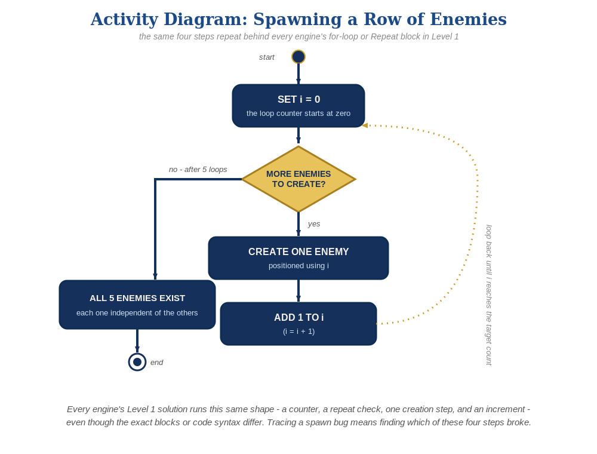
The spawn loop, in general - the same counter, repeat check, creation step, and increment behind Level 1 in every engine, whatever the exact blocks or syntax look like.
- In the Level Blueprint, add an Event BeginPlay node feeding a For Loop node (First Index = 0, Last Index = 4).
- Inside the loop, wire a "Spawn Actor from Class" node (Class = BP_Enemy), with its Transform's Location built from a base position offset by the loop's index (e.g. X = base + Index * 150).
- Click Compile, then Play - you should see a row of enemies, and shooting any one of them should destroy just that one.
Level Blueprint:
Event BeginPlay ->
For Loop(First Index = 0, Last Index = 4) ->
Spawn Actor from Class(BP_Enemy, Transform.Location = (BaseX + Index * 150, BaseY, 0))
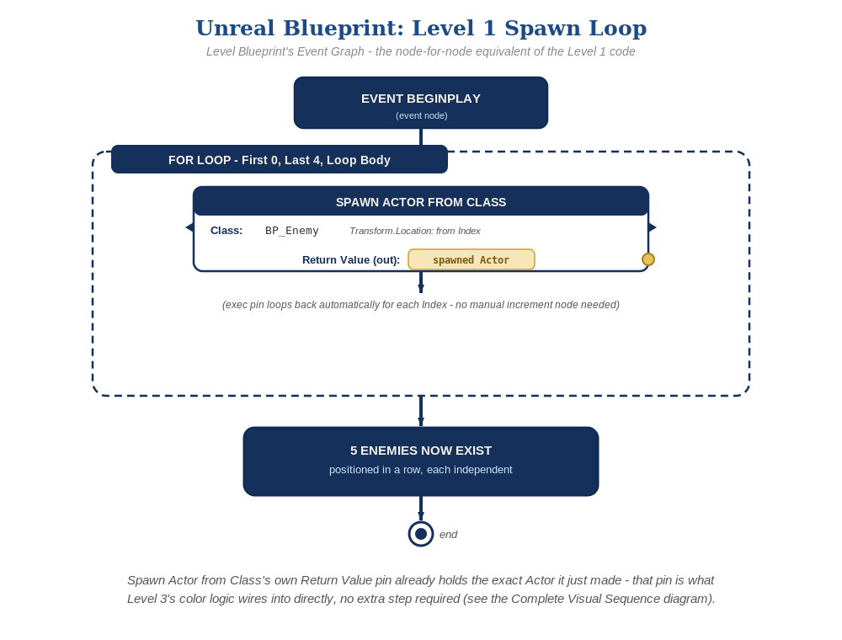
The Level Blueprint's Event Graph, node by node - the node-for-node equivalent of the Level 1 nodes above.

Alternate Path: C++ (code, optional advanced track)
The same for-loop spawn pattern works in C++ instead of Blueprint nodes.
- In your Game Mode's (or a dedicated spawner Actor's) BeginPlay(), add a for loop that calls GetWorld()->SpawnActor<ACppEnemy>() several times, each with a different location.
- Compile, drag a test setup into the level in place of your existing Blueprint spawn logic, Play, and test the same way as the Blueprint path.
// In BeginPlay() of your Game Mode or a spawner Actor:
for (int32 EnemyCount = 0; EnemyCount < 5; EnemyCount++) {
FVector SpawnLoc(BaseX + EnemyCount * 150.f, BaseY, 0.f);
GetWorld()->SpawnActor<ACppEnemy>(SpawnLoc, FRotator::ZeroRotator);
}
This mirrors the Blueprint path's For Loop and Spawn Actor from Class node - same underlying engine calls, just from code. Level 2/3's per-instance logic already lives on ACppEnemy's own BeginPlay()/OnOverlap(), so nothing about them changes based on which path spawned the instances.

Level 2 - Complete (Alpha/Beta)
Every enemy in the row can be individually shot and destroyed without affecting the others, and a bullet that misses every enemy still behaves exactly like it did last week.
- Shoot several different enemies in a row, including some misses - each hit destroys exactly the one BP_Enemy that was actually touched, and every other enemy is unaffected.
- This already works with no extra nodes: BP_Enemy's own Event ActorBeginOverlap and Cast To BP_Bullet logic is self-contained per instance, so every Actor the loop spawns behaves independently and correctly, exactly the way Lesson 4 built it.

Level 3 - Refined (Ready to Publish) - pick any that interest you
- Sound: this already works with no changes - the Play Sound 2D node inside BP_Enemy's overlap event runs independently for every enemy that gets hit.
- Visual: vary each spawned enemy's material color based on the loop's Index, right after Spawn Actor from Class, calling a custom Event on the newly spawned Actor to set it - for a striped row effect. Build the two colors with a Make Linear Color node (not Make Color - Set Vector Parameter Value expects a Linear Color, whose R/G/B fields are 0-1 floats, not Make Color's 0-255 bytes): Dark Red = R 0.8, G 0.1, B 0.2 (a deep crimson red), Light Red = R 0.95, G 0.4, B 0.5 (a lighter dusty rose/pink) - the same two shades used in this course's Unity and Godot tracks, just expressed here as a 0-1 float instead of 0-255. A Select node driven by Index % 2 == 0 picks which one to pass in, so every other enemy is a visibly different shade of red, not a blended new color.
- Structure: keep the Level Blueprint's For Loop limited to just spawning and positioning enemies - resist the urge to also handle collision-response logic there; that still belongs entirely inside BP_Enemy's own Event Graph.

If Something's Wrong
- Only one enemy appears, or they're all stacked in the same spot: confirm the loop's Index output is actually wired into the Transform's Location, not a fixed value.
- Nothing spawns at all: confirm the For Loop's Last Index is actually greater than or equal to its First Index, and that the loop's body pin is connected to Spawn Actor from Class.
- Old and new enemies both appear: confirm the manually-placed Lesson 4 BP_Enemy instance was actually deleted from the level.

Want More?
dev.epicgames.com/community/learning, Student Resource List > Unreal

